Project Design Phase
Problem – Solution Fit

Date | 07 February 2026
Team ID | LTVIP2026TMIDS85199
Project Name | AutoSage App Using Gemini Flash
Maximum Marks | 2 Marks

Problem – Solution Fit Template:
The Problem-Solution Fit means identifying the real problems faced by vehicle buyers and ensuring that the AutoSage solution effectively addresses those issues using AI-powered vehicle analysis.
Purpose:
- Solve vehicle comparison and information access problems efficiently.
- Help users make informed vehicle purchase decisions.
- Provide AI-based insights using Gemini Flash.
- Improve user confidence while selecting vehicles.
- Simplify vehicle analysis through image-based processing.
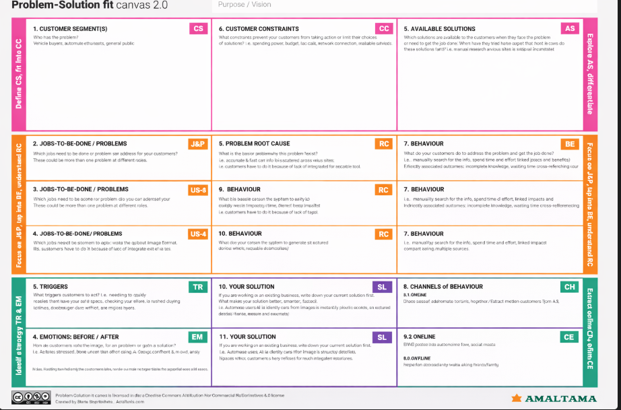
Template:

